Tarea 3

1 – Para el circuito inferior detalle lo siguiente:

* Utilice DeMorgan para encontrar su equivalente
* Escriba la ecuación lógica
* Escriba la tabla de la verdad

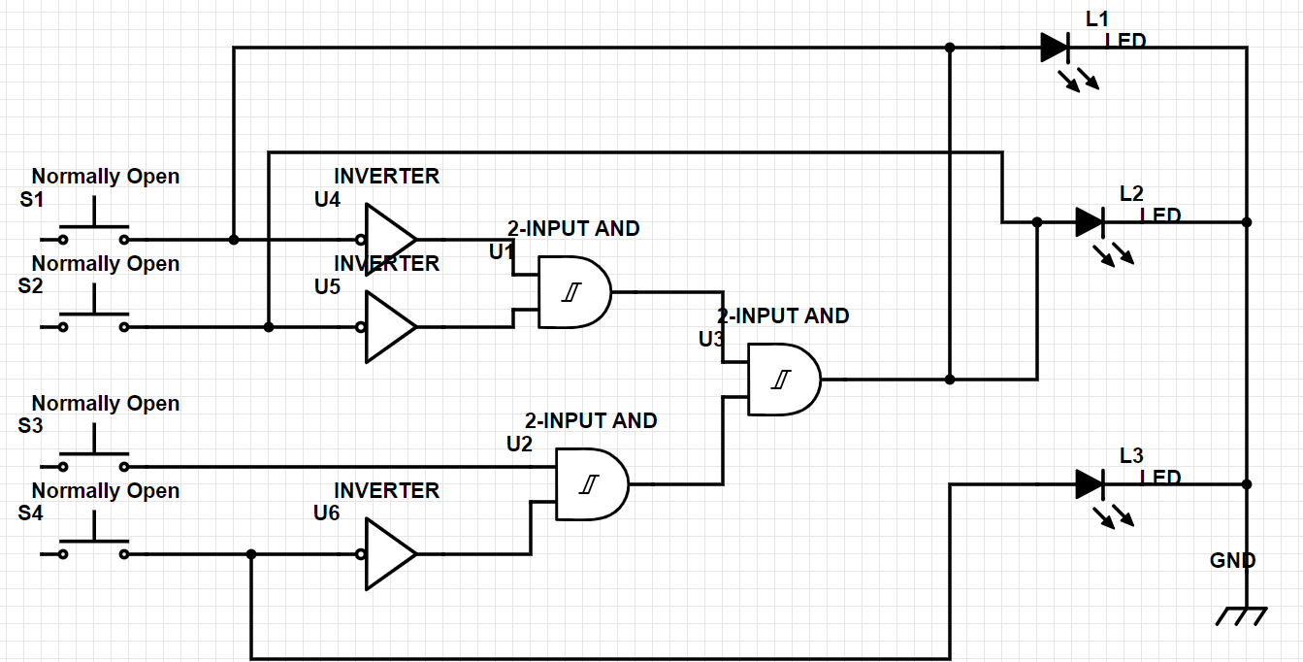

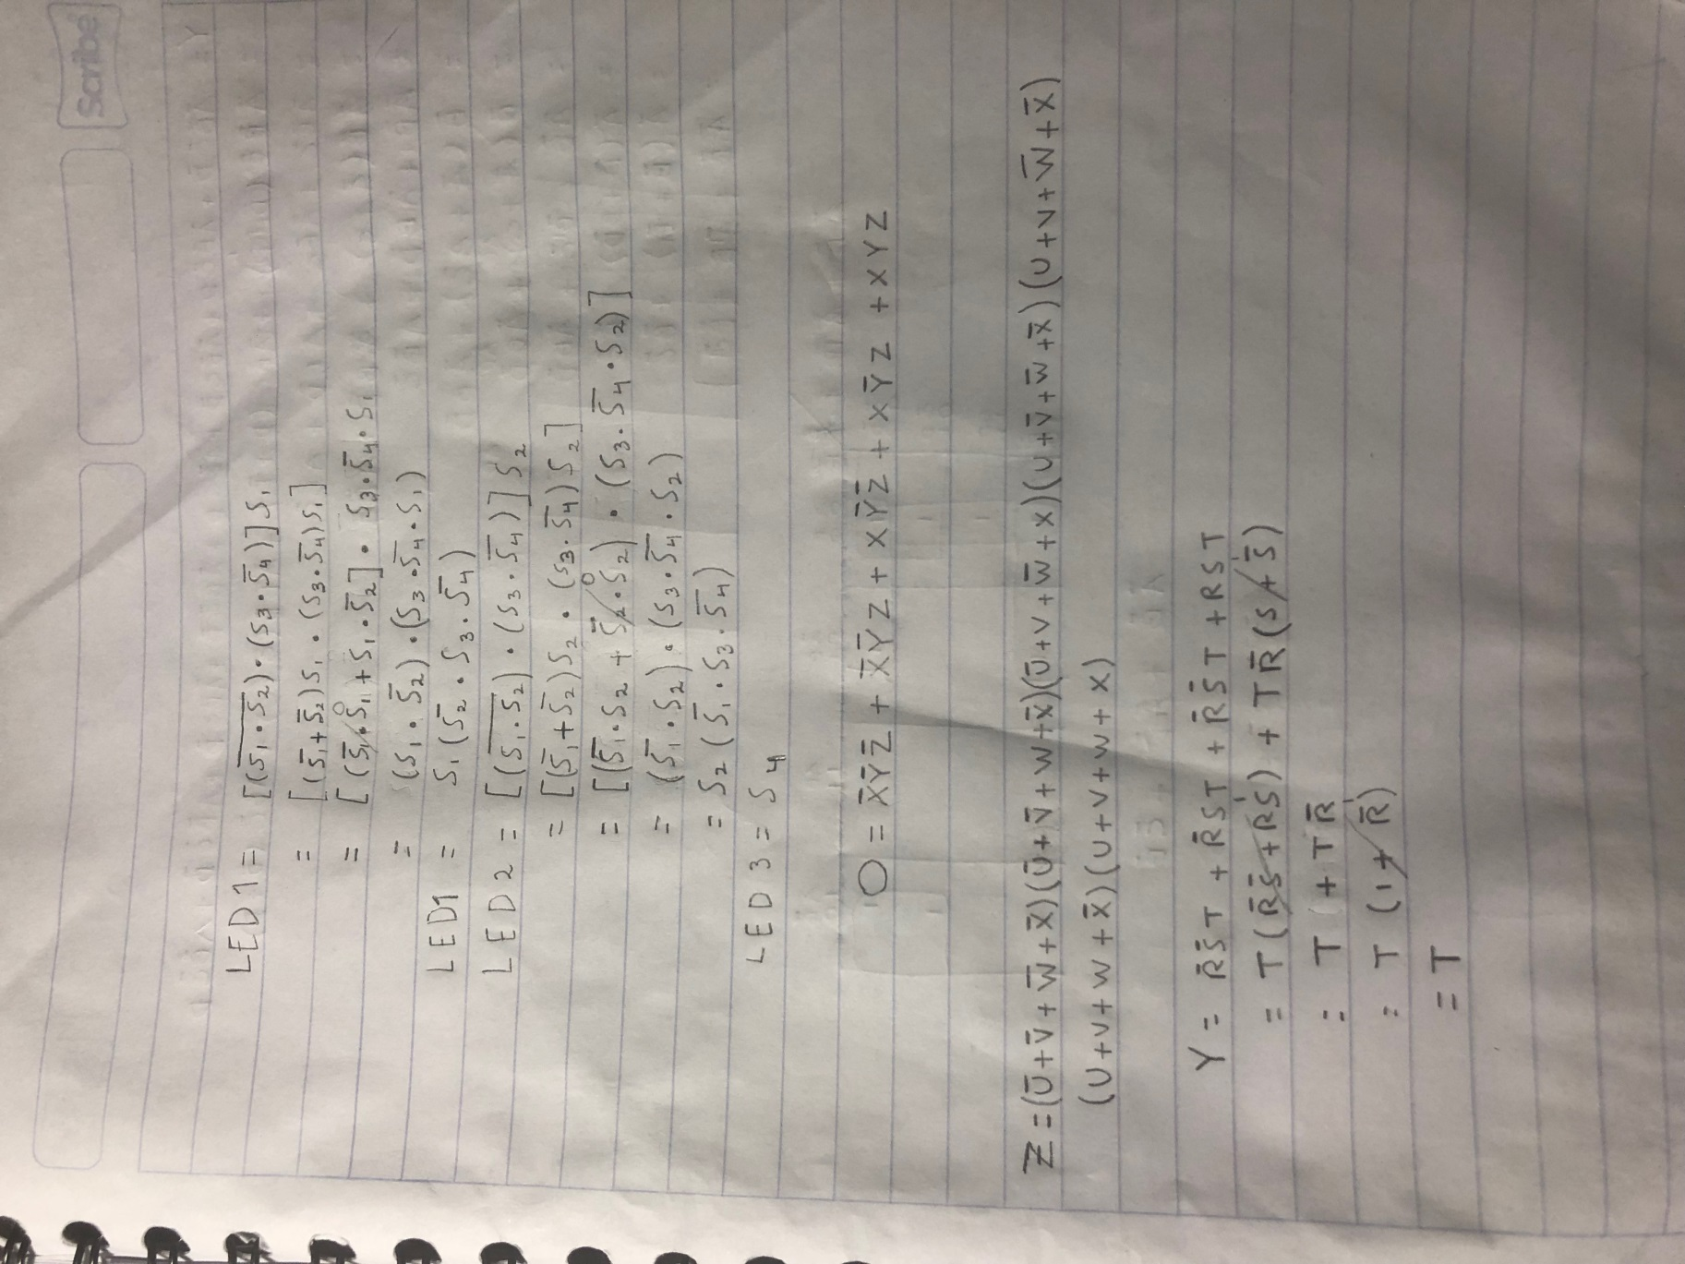

|  |  |  |  |  |  |  |
| --- | --- | --- | --- | --- | --- | --- |
| S1 | S2 | S3 | S4 | ***LED1 (SALIDA)*** | ***LED 2 (SALIDA)*** | ***LED3 (SALIDA)*** |
| 0 | 0 | 0 | 0 | **0** | **0** | **0** |
| 0 | 0 | 0 | 1 | **0** | **0** | **1** |
| 0 | 0 | 1 | 0 | **0** | **0** | **0** |
| 0 | 0 | 1 | 1 | **0** | **0** | **1** |
| 0 | 1 | 0 | 0 | **0** | **0** | **0** |
| 0 | 1 | 0 | 1 | **0** | **0** | **1** |
| 0 | 1 | 1 | 0 | **0** | **1** | **0** |
| 0 | 1 | 1 | 1 | **0** | **0** | **1** |
| 1 | 0 | 0 | 0 | **0** | **0** | **0** |
| 1 | 0 | 0 | 1 | **0** | **0** | **1** |
| 1 | 0 | 1 | 0 | **1** | **0** | **0** |
| 1 | 0 | 1 | 1 | **0** | **0** | **1** |
| 1 | 1 | 0 | 0 | **0** | **0** | **0** |
| 1 | 1 | 0 | 1 | **0** | **0** | **1** |
| 1 | 1 | 1 | 0 | **0** | **0** | **0** |
| 1 | 1 | 1 | 1 | **0** | **0** | **1** |

Problemas 2 y 3: Resuelva 1 de 2

2 – Encuentre el diagrama lógico de la siguiente expresión (no simplificar).

Nota: Puede dibujarlo si gusta con <https://www.digikey.com/schemeit>

3. Para la siguiente tabla de verdad encuentre la ecuación de suma de productos (Salida = O). (No simplificar)

|  |  |  |  |
| --- | --- | --- | --- |
| X | Y | Z | **O** |
| 0 | 0 | 0 | **1** |
| 0 | 0 | 1 | **1** |
| 0 | 1 | 0 | **0** |
| 0 | 1 | 1 | **0** |
| 1 | 0 | 0 | **1** |
| 1 | 0 | 1 | **1** |
| 1 | 1 | 0 | **0** |
| 1 | 1 | 1 | **1** |

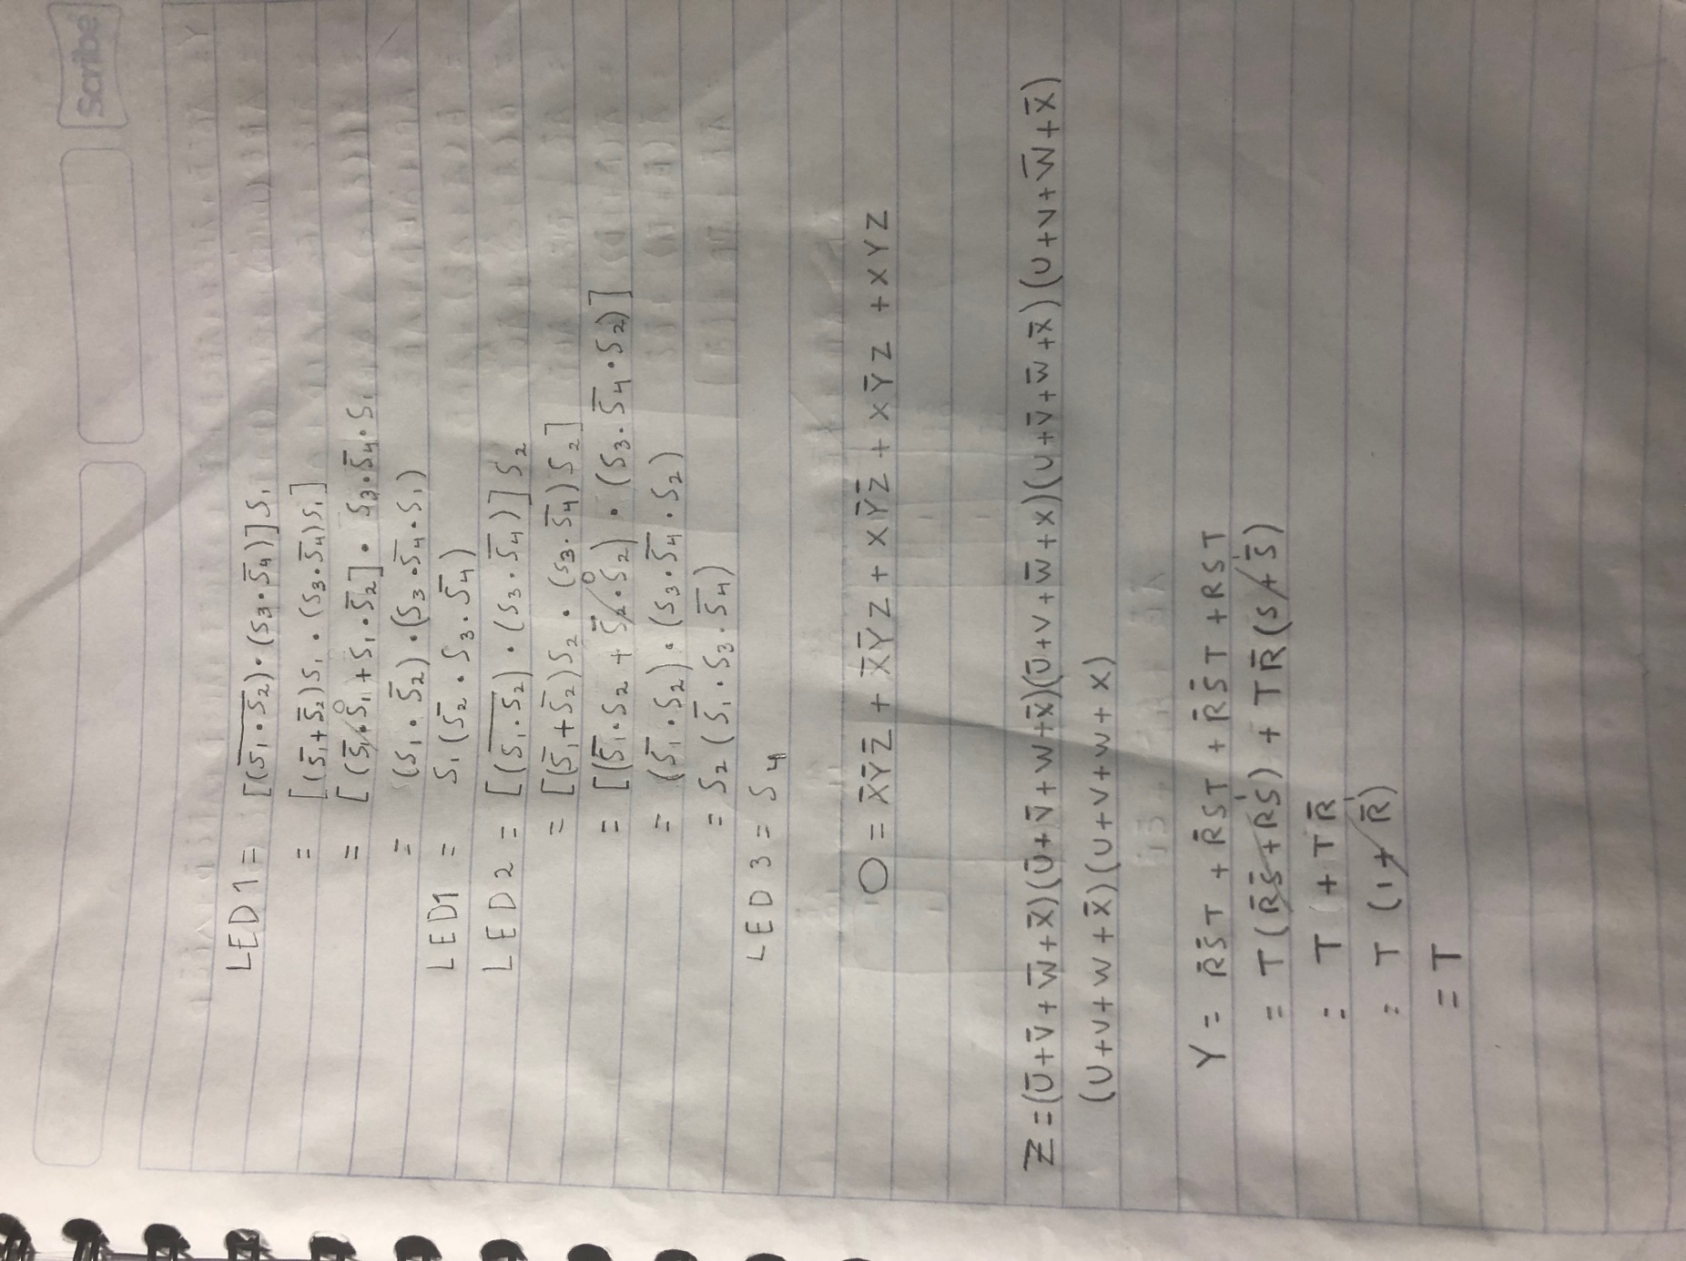

Problemas del 4 al 6: Resuelva 2 de 3

4. Para la siguiente tabla de verdad encuentre la ecuación en productos de suma (Salida = Z). (No Simplificar).

|  |  |  |  |  |
| --- | --- | --- | --- | --- |
| U | V | W | X | **Z** |
| 0 | 0 | 0 | 0 | **1** |
| 0 | 0 | 0 | 1 | **0** |
| 0 | 0 | 1 | 0 | **1** |
| 0 | 0 | 1 | 1 | **0** |
| 0 | 1 | 0 | 0 | **0** |
| 0 | 1 | 0 | 1 | **1** |
| 0 | 1 | 1 | 0 | **0** |
| 0 | 1 | 1 | 1 | **0** |
| 1 | 0 | 0 | 0 | **1** |
| 1 | 0 | 0 | 1 | **0** |
| 1 | 0 | 1 | 0 | **0** |
| 1 | 0 | 1 | 1 | **0** |
| 1 | 1 | 0 | 0 | **1** |
| 1 | 1 | 0 | 1 | **0** |
| 1 | 1 | 1 | 0 | **1** |
| 1 | 1 | 1 | 1 | **1** |

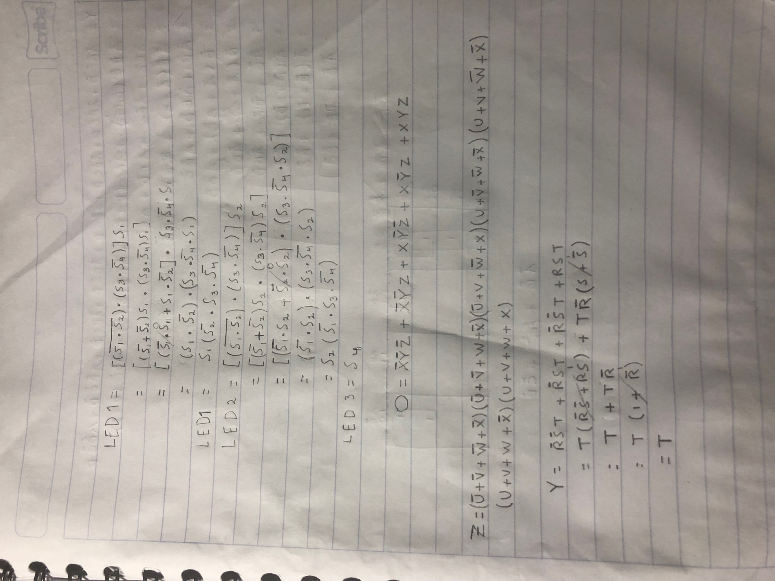

5. Use algebra booleana para simplificar las siguiente expresión:

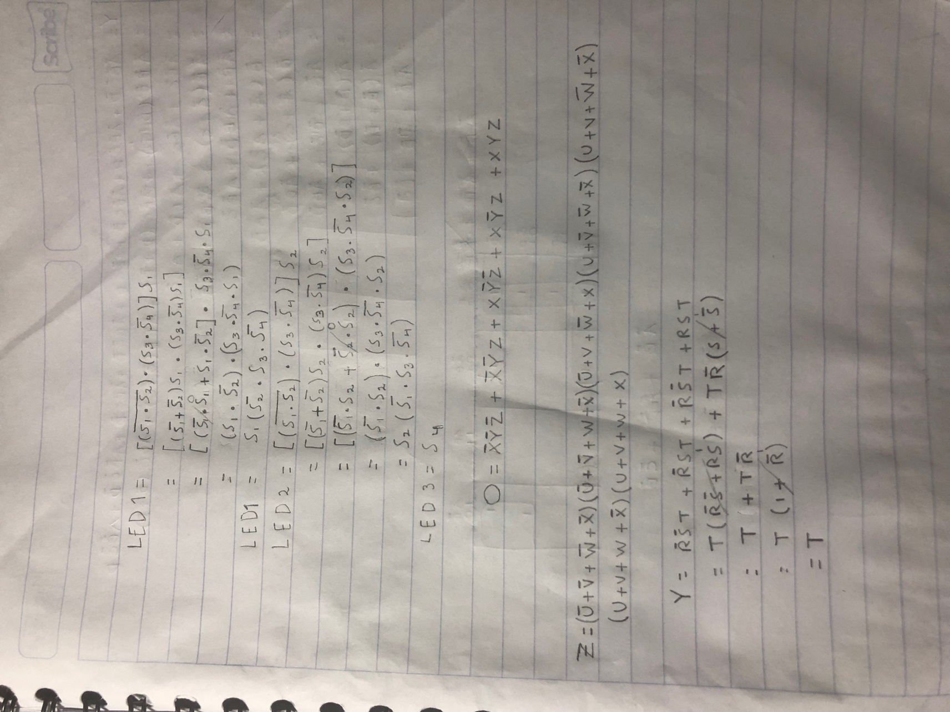

6. Use reglas de simplificación para algebra booleana y por medio de mapa de Karnaugh encuentre la suma de productos de:

|  |  |  |  |  |
| --- | --- | --- | --- | --- |
| A | B | C | D | **Y** |
| 0 | 0 | 0 | 0 | **1** |
| 0 | 0 | 0 | 1 | **1** |
| 0 | 0 | 1 | 0 | **1** |
| 0 | 0 | 1 | 1 | **1** |
| 0 | 1 | 0 | 0 | **1** |
| 0 | 1 | 0 | 1 | **0** |
| 0 | 1 | 1 | 0 | **1** |
| 0 | 1 | 1 | 1 | **0** |
| 1 | 0 | 0 | 0 | **1** |
| 1 | 0 | 0 | 1 | **1** |
| 1 | 0 | 1 | 0 | **0** |
| 1 | 0 | 1 | 1 | **0** |
| 1 | 1 | 0 | 0 | **0** |
| 1 | 1 | 0 | 1 | **0** |
| 1 | 1 | 1 | 0 | **0** |
| 1 | 1 | 1 | 1 | **0** |

7. Resuelva el siguiente problema utilizando Productos de suma y el mapa de Karnaugh

|  |  |  |  |  |
| --- | --- | --- | --- | --- |
| A | B | C | D | **Y** |
| 0 | 0 | 0 | 0 | **0** |
| 0 | 0 | 0 | 1 | **X** |
| 0 | 0 | 1 | 0 | **1** |
| 0 | 0 | 1 | 1 | **0** |
| 0 | 1 | 0 | 0 | **X** |
| 0 | 1 | 0 | 1 | **1** |
| 0 | 1 | 1 | 0 | **0** |
| 0 | 1 | 1 | 1 | **X** |
| 1 | 0 | 0 | 0 | **1** |
| 1 | 0 | 0 | 1 | **0** |
| 1 | 0 | 1 | 0 | **1** |
| 1 | 0 | 1 | 1 | **X** |
| 1 | 1 | 0 | 0 | **0** |
| 1 | 1 | 0 | 1 | **1** |
| 1 | 1 | 1 | 0 | **X** |
| 1 | 1 | 1 | 1 | **X** |

